**Association rules exploration**

We also tried to search the number of rules changing the value of minimum support. Keeping min_sup = 20 we obtained the line plot as in *Figure 1*, with minimum dimension of itemset equal to 3.

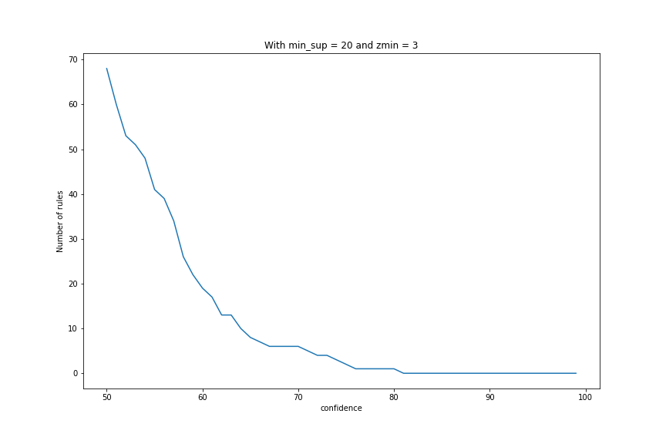

Figure 1: # of rules per confidence given min_sup = 20 and zmin = 3.

We can see that we can get at least slightly more than 80% of confidence.

Increasing *zmin* from 3 to 4 we had to decrease the minimum support from 20% to 10%, the result is shown in *Figure 2*.

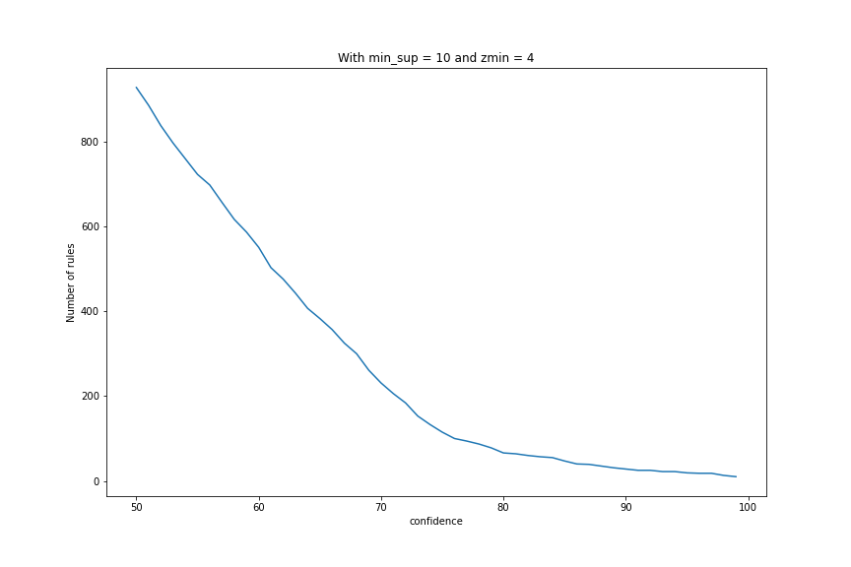

Figure 2: # of rules per confidence given min_sup = 10 and zmin = 4.

With a lower minimum support we can reach high confidence values, although 100% shouldn’t be considered because we can never be 100% sure of anything.